March 28, 2022; Session 1; 1:00 pm – 5:00 pm

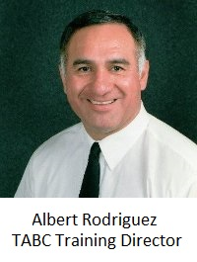
Alex Rodriguez – Officer Involved Shooting Science

Captain Rodriguez has consulted, investigated, and testified in over 2,500 officer-involved Use of Force cases throughout the United States. On numerous occasions he has been the guest speaker for the Texas Bar, the Texas and California Homicide Investigators’ Conference, and Vancouver, Canada’s International Homicide Investigators Conference. He has studied and researched the subject of Law Enforcement Response to Resistance and Officer Involved Shootings for over thirty-five years. Captain Rodriguez is a graduate of the 147th Session of the FBI National Academy. He has instructed law enforcement officer throughout the United States, Canada, and Mexico to include FBI Agents and the Texas Rangers. According Rodriguez “Experienced law enforcement officers are experts at reading ‘Body Language,’ but not necessarily experts at articulating what they see and/or what they see means to them.”. . In 2010, after 33 ½ years of service, he honorably retired from the DPS. In 2010, he joined the Texas Alcoholic Beverage Commission as a Lieutenant in Internal Affairs. In 2013, he was promoted to Captain within the Training Division and presently serves in that capacity.

March 29, 2022; Session 1; 8:00 am – 12:00 pm

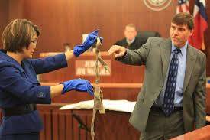
Connie Spence – Murder Mistakes
Connie Spence is a former prosecutor for the Harris County District Attorney’s Office where she has successfully prosecuted numerous high profile murder cases. Connie Spence will conduct a four hour presentation on how to avoid mistakes in a murder investigation by highlighting 5 actual murder cases. Mrs. Spence is now a Prosecutor for the Attorney General’s Office on Human Trafficking Cases. As a prosecutor in the Human Trafficking and Transnational Organized Crime Section (HTTOC) she has been assigned to in many cases travel state wide to end human trafficking in the State of Texas through aggressive criminal prosecution and civil actions to hold offenders accountable. Topics such as Non-Custodial Interviews, Juvenile statements, the use of Cell Phones and how mistakes made could have detrimental effects on your case.

March 29, 2022; Session 2; 1:00 pm – 5:00 pm

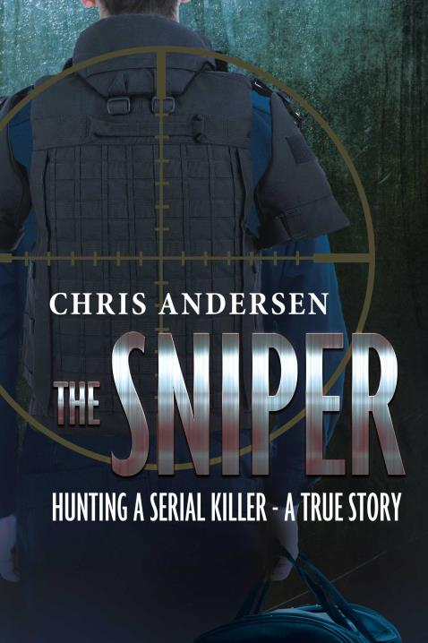
Chris Andersen – The Sniper: Hunting of a Serial Killer

Author of the book The Sniper: Hunting of a Serial Killer. Houston has long been known as the armored truck robbery capital of the world! Beginning in 2015, the law enforcement and armored truck community in Houston faced an armored truck robbery crew employing deadly tactics. In one example of an ambush style robbery, a Brinks courier was gunned down at close range and the crew was able to empty the armored truck of nearly $1 million in cash! Chris Andersen is a 39 year veteran of the Houston Police Department has had many assignments in his career including working as a “homicide cop” and working as a Sergeant supervising a SWAT Assault Team. Sgt. Chris Andersen’s team utilized advanced surveillance techniques to dismantle a violent commercial robbery crew solving several murders of prominent business men.

March 30, 2022; All Day Session; 8:00 am – 5:00 pm

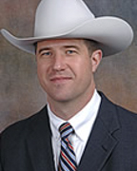
Texas Ranger Sergeant - James Holland – Investigation of a Serial Killer

James B. Holland is a Texas Ranger assigned to the Unsolved Crime Investigation Program; responsible for cold case homicide, serial killer, ritualistic killing, and dismemberment investigations. Ranger Holland has worked numerous high profile homicide investigations and apprehended a vast number of serial killers. Ranger Holland is considered a Subject Matter Expert in interview and interrogation, rapid assessment interview techniques, as well socio and psychopathic mind sets and interview techniques. Ranger Holland is most notably well known for his more than 650 hours of interviews over 16 months with serial killer Samuel Little. Little confided to Ranger Holland that he had strangled 93 women during a 40-year nomadic rampage from Florida to California, a tally that ranks him among the nation’s most prolific serial killers. Ranger Holland has been featured on 48 hours, 60 minutes, Podcast Murder book, Texas Monthly, and featured in every major U.S. newspaper. His story has been told worldwide.

Chief Deputy Brian Harris – Investigation of a Serial Killer

Brian Harris has been in law enforcement for 35 years and is now retired from the Houston Police Department. He was a murder cop for 22 years working a large volume of homicide investigations. Chief Harris was most recently the homicide host for “Inside the Mind of a Serial Killer Season 2” which premiered on Netflix and can be seen on Amazon. He has been featured in Time magazine, ABC’s 20/20 and Primetime, 48 hours, Forensic Files, The Interrogator, Killer Confessions, Women that Kill, and numerous other shows on I.D. and Discovery. He will be featured on the American Detective with Joe Kenda. Harris has trained hundreds of law enforcement officers nationally and internationally in Interviewing and Interrogations, Homicide Investigation, and a variety of other courses. Currently he is the Chief Deputy for Harris County Pct. 5 Constable Ted Heap (a department of 426 sworn) and trains across the United States. His courses can be found at BrianHarrsinterviewing.com

March 31, 2022, Closing Session; 8:00 am – 12:00 pm

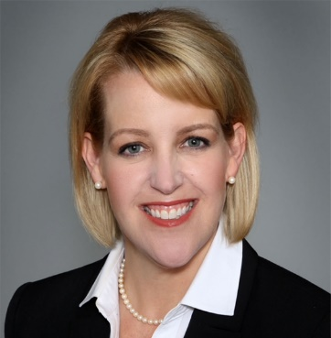
ADA Katherine McDaniel – Legal Updates

Katherine McDaniel is a native Texan and a dedicated public servant. Mrs. McDaniel is currently the First Assistant District Attorney in the Kendall County District Attorney’s Office. As First Assistant, Mrs. McDaniel is responsible for setting policy, supervising attorneys, paralegals, victim coordinators, and other staff. Prior to January 2017, she was a Chief Prosecutor in Harris County, where she was personally responsible for Capital murder and murder cases, as well as supervising junior prosecutors and staff. Katherine McDaniel has worked on a wide variety of tough cases ranging from DWI, child abuse, sexual assault, capital murder, organized crime, and more. Her success in the field allowed her to supervise and train numerous other prosecutors

