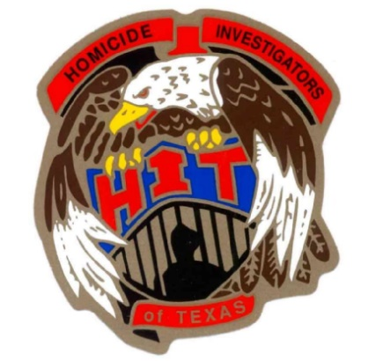

**2025 HOMICIDE INVESTIGATORS OF TEXAS CONFERENCE**

**37th ANNUAL TRAINING ITINERARY**

**Monday, March 24th**

8:00 A.M - 12 noon **Registration**

12:30 P.M. – 1:00 P.M. **Opening ceremony**

1:00 P.M. – 5:00 P.M. **Outlaw Motorcycle Gangs/Mongrels**

**Billy Queen/ATF (Ret.)** will take a deep dive into Operation Ivan, an ATF uncover operation where Billy infiltrated the Mongol MC for 28 months. He will discuss the dynamics of OMGs and how it relates to violent crimes, including murder, and how they subsequently secured 53 convictions.

**Tuesday, March 25th**

08:00 A.M. - 12:00 P.M. **No Body Homicide Investigations**

**Det. Summer Benton/Atlanta P.D./First 48** Will discuss the dynamics of No-Body homicide investigations through a case study of her personal investigation and the subsequent conviction.

12:00 P.M. – 1:00 P.M. **Lunch** (on your own)

1:00 P.M. – 3:00 P.M. **Fundamentals of Forensic Anthropology**

**Dr. Sarah Getz/Office of the Chief Medical Examiner for the State of Oklahoma** will discuss the fundamentals of Forensic Anthropology, to include a case study of personal investigations.

3:00 P.M. – 5:00 P.M. **Digital Forensics in a Homicide Investgation**

**Eric Devlin/Lonestar Forensic Group** will discuss the use of digital evidence and various types of digital evidence in a homicide investigation.

**Wednesday, March 26th**

8:00 A.M. – 12:00 P.M. **Catching a Serial Killer/Night Stalker Case**

**Gil Carillo/Los Angeles Sheriff’s Dept. (Ret.)** will discuss the “Night Stalker” investigations, a serial killer with no pattern. How using small details of what appeared to be random crimes led him to believe they were related.

12:00P.M. – 1:00 P.M.  **Lunch** (on your own)

1:00 P.M. – 4:00 P.M. **Using Multiple Technologies and Resources to Solve Homicides**

**Det. Lawrence Saiz/San Antonio PD** will discuss using NIBIN and other resources to tell how he caught a killer in a down town San Antonio drive by shooting.

4:30 P.M. -5:00 P.M. **Business Meeting**

**Thursday, March 27th**

8:00 A.M. - 12:00 P.M. **Abstract Investigative Leads for Cold Cases**

**Rob Moore and Susan Davis/University of North Texas Forensic Lab** will discuss how the University of North Texas Center for Human Identification uses Forensic Genetic Genealogy for potential investigative leads, and how it is available to law enforcement at no charge.

12:00 P.M. **ADJOURN**

Thanks to Everyone, “Have a Safe Trip Home”

NOTE – Speakers and times are subject to change.